**HALL BOOKING API**

**POST MAN DOCUMENTATION :**

<https://documenter.getpostman.com/view/36251176/2sA3kaDKJ4>

**1.Creating a Room**

<http://localhost:4000/room/createroom>

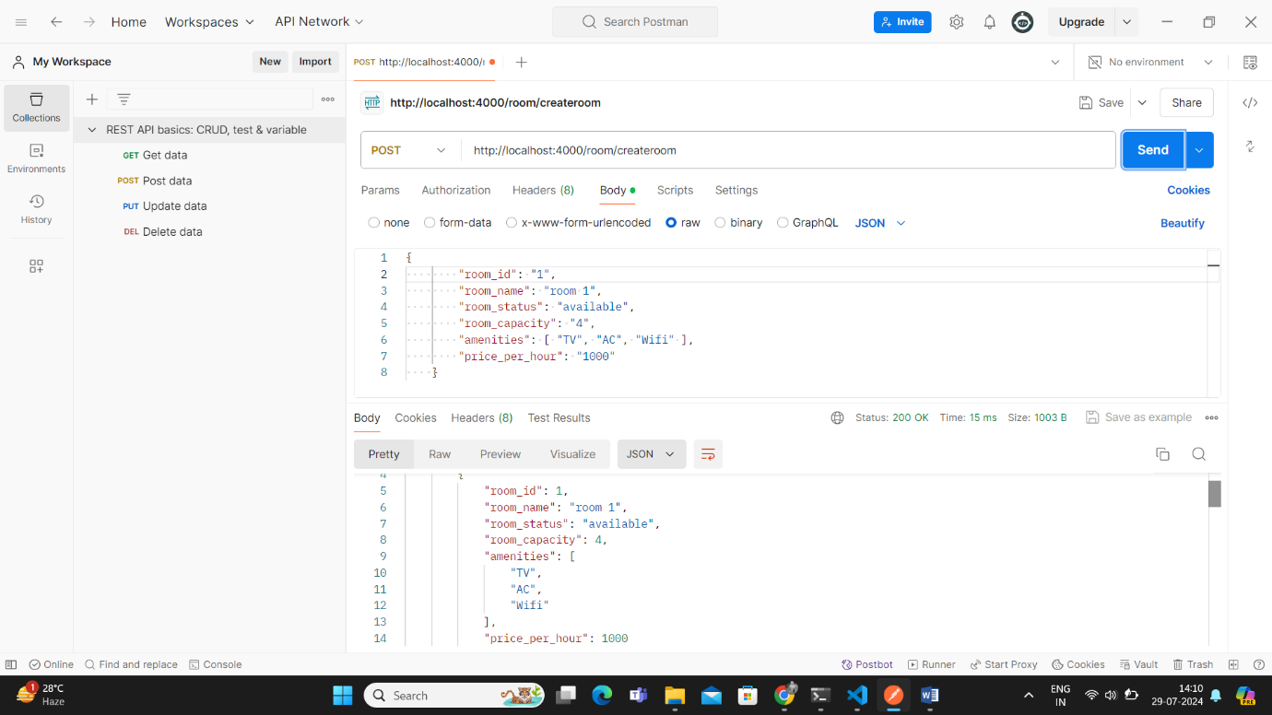

2.**Booking a Room**

<http://localhost:4000/booking/bookroom>

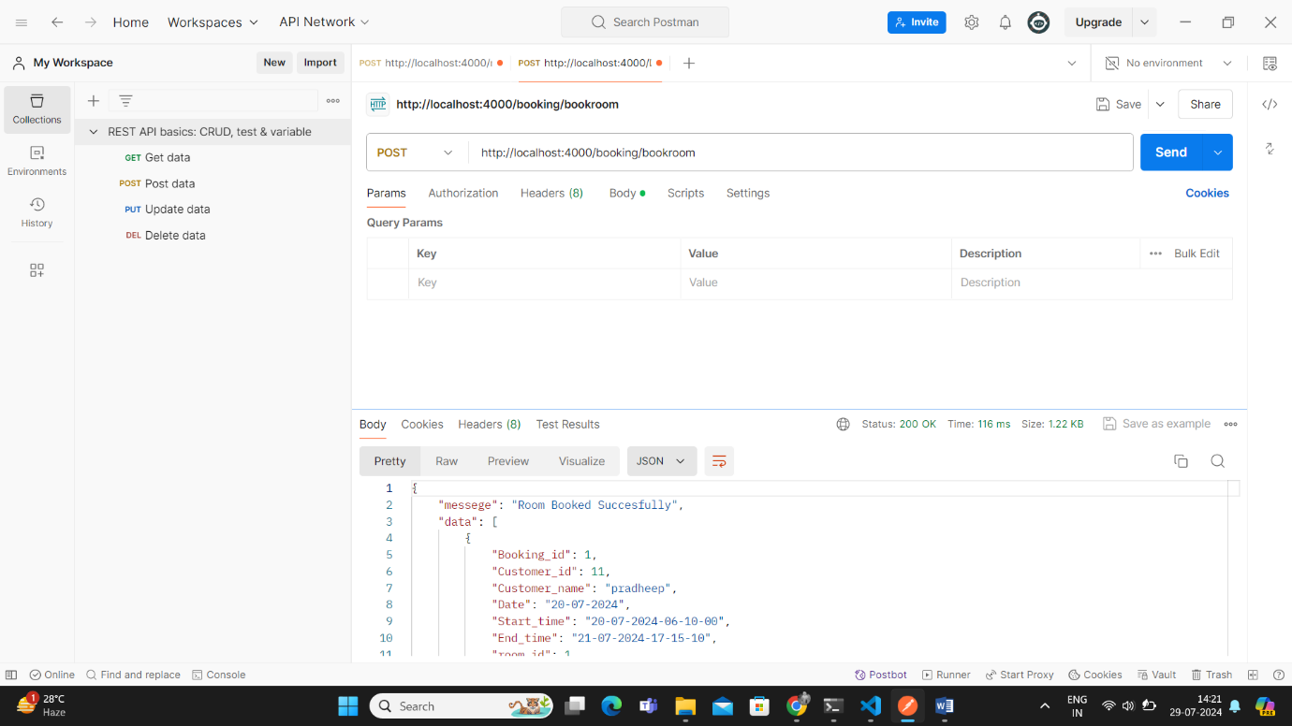

**3.Booked Room Details**

<http://localhost:4000/booking/bookedroomdetails>

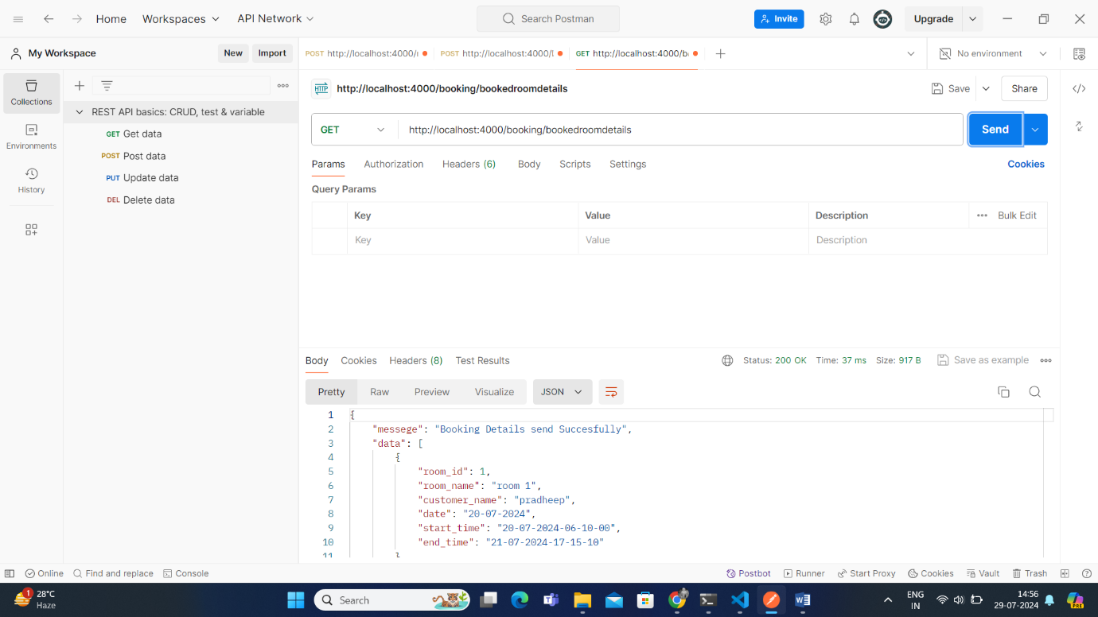

**4.Customer Details**

<http://localhost:4000/booking/getcustomerdata>

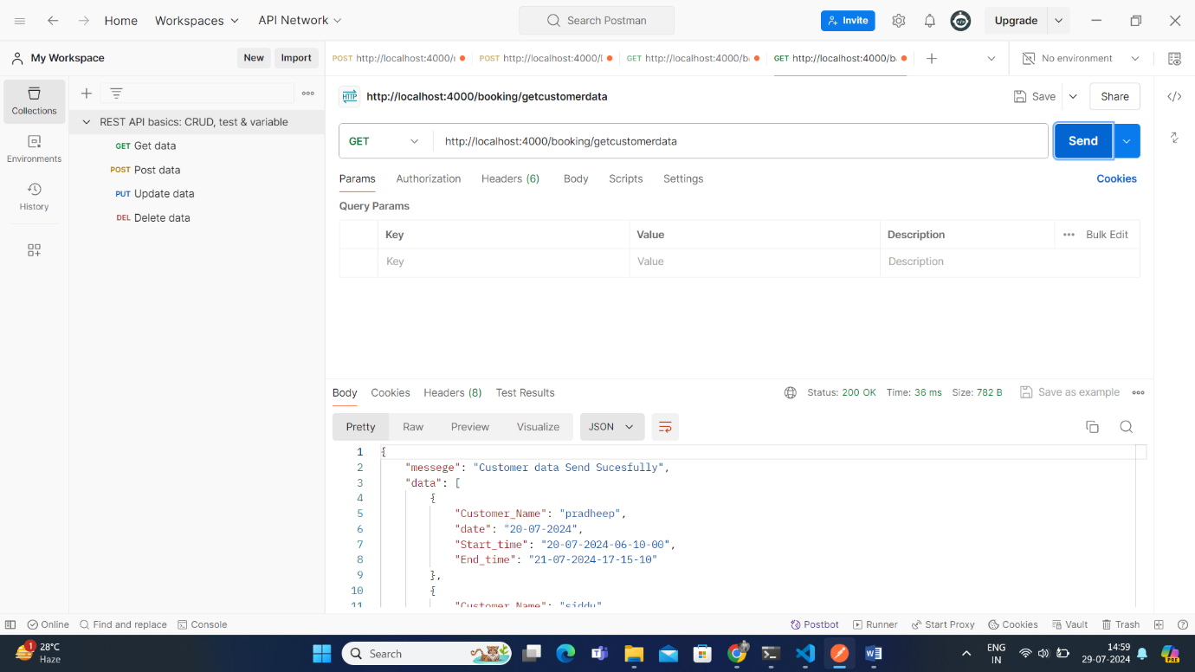

**5.How many times Customer Booked Room with Details**

[http://localhost:4000/booking/getcount/12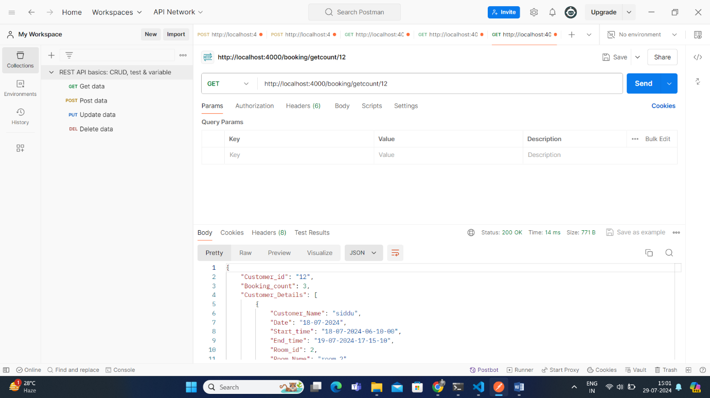](http://localhost:4000/booking/getcount/12#)

**6.Get Rooms Details**

<http://localhost:4000/room/getrooms>

